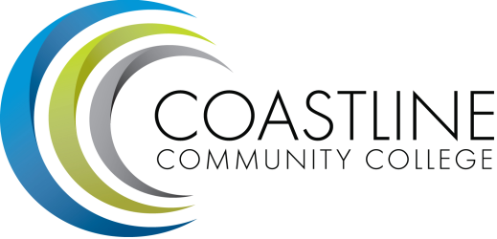
Accreditation Steering Committee Agenda
02/24/2017
9:30 a.m. - 11:00 a.m.
Le-Jao Center 210

Committee Mandate: While there is not yet a formal mandate for this particular meeting, the purpose of this group is to prepare to convene the Accreditation Steering Committee to produce the next Institutional Self-Evaluation Report (ISER) for our own quality control and Accreditation compliance.

- CALL TO ORDER
  - Roll Call
  - Welcome
  - Adoption of Agenda

- SPECIAL REPORTS & UPDATES
  - Overview of process including presentation of report production timeline (D. Pittaway / A. Zentner)
  - Review of past self-evaluation report, findings, and follow-up / midterm report (D. Pittaway / A. Zentner)
  - Roles and responsibilities (V. Rodriguez)
  - Expectations (D. Pittaway / A. Zentner/ V. Rodriguez)
  - Writing guidelines (D. Pittaway / A. Zentner) (STEPSS)
  - Evidence (D. Pittaway / A. Zentner)

- ACTION ITEMS

- STANDING REPORTS

- DISCUSSION ITEMS
  - Team structure and participation of Coastliners
  - Quality Focus Essay
5.3 General questions / discussion
5.4 Next steps (convening Accreditation Steering Committee)

- ANNOUNCEMENTS (1-2 minutes per)

- ADJOURNMENT

Electronic Materials to be forwarded to members:
- ACCJC Guide to Evaluating Institutions
- ACCJC Standards
- Report Production Timeline

